URECA records for 3, 4 and 8 December 2025. （mingzhi）

Day 1:
Summary:
- Adjust new recipe on new cleaver (new CT-106), found optimized cleaving parameters for flat cleave, HCF (recipe name: HCF 360).
- Adjust Right side clamp force, for stable angle cleaving.

Data: (Parameter for Best result: )
[HCF 360]
2800 right clamp force
700 gf – 1000 gf left clamp force
Cleave tension: 725 gf
Obtain 0.0° flat cleave several times.
Full raw data:
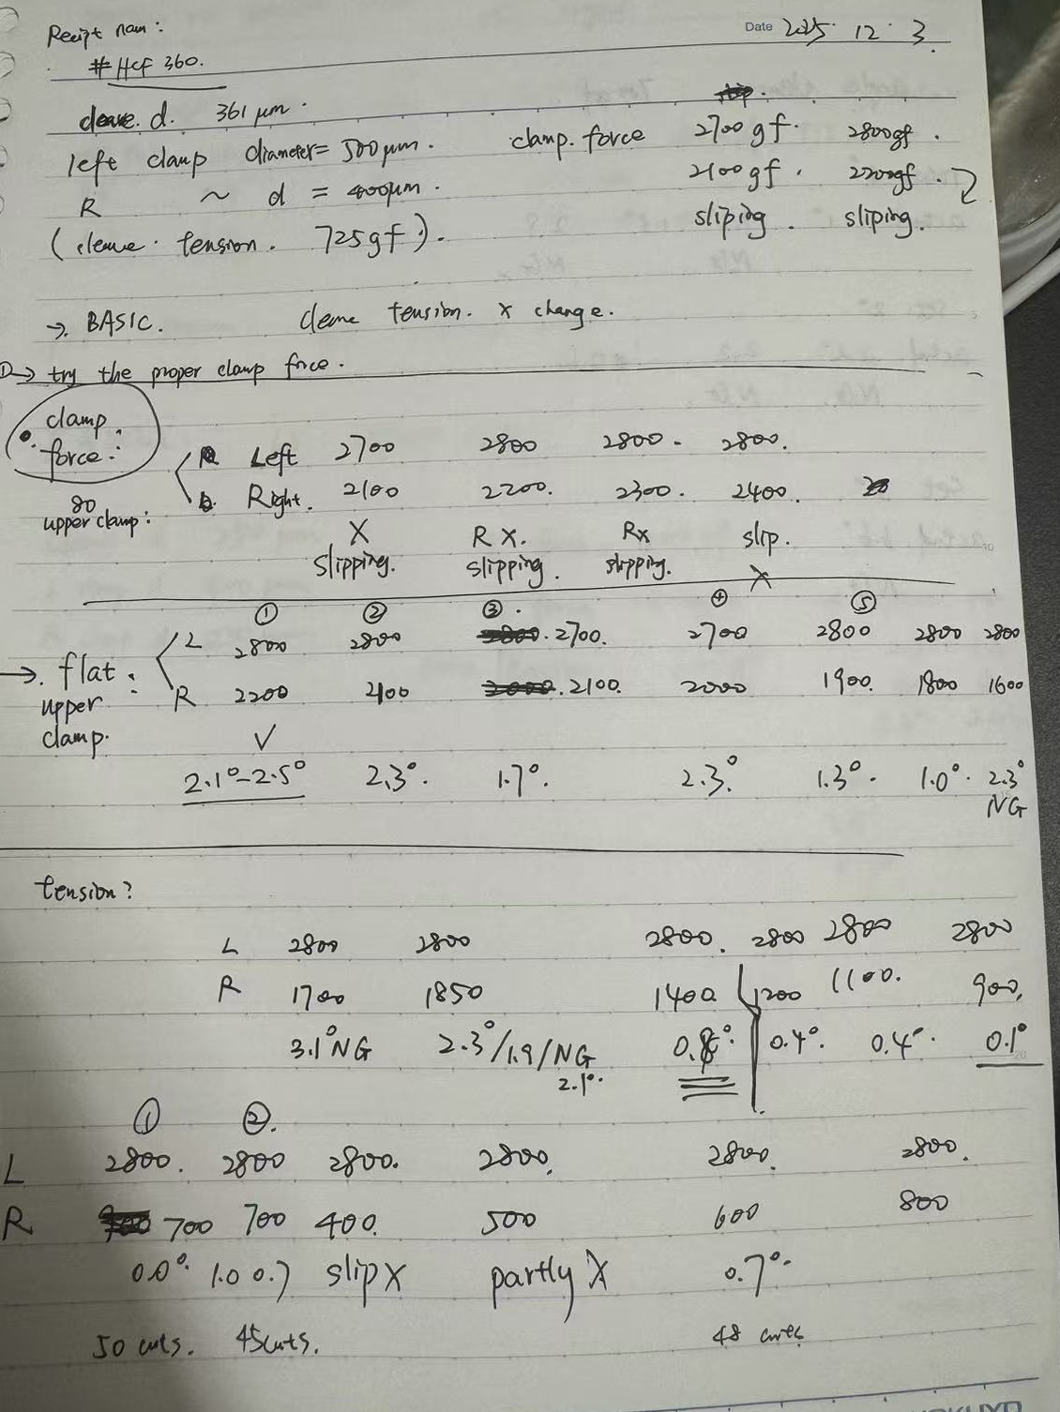

Result:
For HCF: (left v-groove 500-500, right v-groove 400-flat upper)
clamp force L 2800gf, R 700gf-1000gf can get flat cleave under 0.4°.
slipping limit: R 500 gf

Day 2:
Summary:
- Adjust parameters for cleaving passive fiber. (recipe name: 65: 25/250/CG).
25/250/CG:
Cleave d: 250um
L clamp d: 400um L clamp force: 1100gf
R clamp d: 250um R clamp force: 1300gf
Cleave tension: 637gf
- Test power transmission YDF-HCF with flat cleave and angle cleave, with and without angle alignment.
- Note: next semester there will be an intern student joining, and next year there will be a large new laser machine (and we will study on that wavelength). Also we will got another certain type of HCF which may slightly different from current one to make sure the wavelength fall in the ideal mode and low loss area so that we can further study the high-power transmission characteristics.
- To be finished: stable and ideal parameters for angle cleaving of YDF passive fiber still need to be worked out.

Data:
YDF passive fiber: 250/400 μm
index | YDF | HCF | Angle alignment | transmitted power | length
1 | 0.3° | 0.4° | NO | 13.6mW | 1m HCF
2 | 0.3° | 0.4° | YES | 13.7mW | 1m HCF
3 | 0.3° | 0.6° | NO | 0mW | 10m HCF
4 | 0.3° | 0.6° | YES | 0mW | 10m HCF
Injection power：
975nm | 288mA | 16.3mW (After YDF)

Result:
High loss happened in HCF currently, 10m HCF there is no power outcome.
Angle cleaving is effective at least not worse under 0.4° test.

Dr. Charu’s Record for day 2.
This is what I have in my notes from last time. Sharing it here so we are on the same page.
- you now have a very predictable recipe for flat cleave (less than 0.5 degrees) of passive as well as HCF. I hope you have the details in your record- the program numbers, the optimized clamp force, cleave tension, v-groove sizes for lower and upper size on both left and right side.
- angle cleaving works well for HCF, but not so much with passive fiber. You will optimize that today.
- when we used flat-cleaved fibers (0.3 and 0.4 degrees, respectively), with fiber angles 0 and 0.1 degrees, the power output from 10 m fiber spooled on the drum, was nearly zero. But after 1 m long fiber, we received 78.7% of launched power. This shows that the 976 nm wavelength is close to high-loss region in this fiber and hence, we cannot use very long length. Given that the fiber has high loss, 78.7% transmission efficiency after 1 m would be acceptable.
- When we introduced theta alignment on this same set of fibers, the efficiency increased slightly to 82.4%. This proves that angle alignment helps, even with small angles.
- Note: whenever we compare coupling efficiencies, try to keep the HCF in similar orientation because if 976 nm is close to the high-loss band, then any sharp bend can introduce extra loss.

URECA Day 3 Recording: (2025.12.9)
3.1 Optimized YDF & HCF angle cleaving parameters for 1°（HCF not stable outcomes）
3.2 Measuring power transmission for angle cleaved HCF & YDF.

3.1 Angle cleaving parameters: (haven’t find out better and stable parameter.)
①Based on program HCF 360: (Adjust clamp force R 1000gf)
Rotate 2°-2.4° usually can get around 1.0° outcomes.

②Based on program 25/250/CG: (adjust clamp force R 1600-1700gf)
Rotate around 4 degree, usually get 0.8°-1.6°

3.2 Power transmission measurement:
parameters:
Test | L (YDF) | R (HCF) | Theta Alignment | power after YDF | power after HCF | EFFICIENCY
1 | 1.0° | 1.1° | no | 14.5mW | 12.9mW | 88.96%
 | 0.9° | 1.0° | yes | 14.5mW | 12.8mW | slightly lower
2 | 1.0° | 1.2° | no | 14.3mW | 12.7mW | 89.43%
 | 0.9° | 1.2° | yes | 14.3mW | 12.5mW | slgihtly lower.
 | 83cm HCF
 | gap set : | 10μm
 | tried to reduce gap, got low transmission power

3.3Small reflection:
①Although angle cleaving with theta alignment do help improve the transmission efficiency with small angles (0.4°), here when increase to 1.0° the power seem decrease after theta alignment. The problem is unknown and need to find out later. (maybe with new laser and new fiber.)
We also encountered this problem during semester according to Ranya’s Record (2025 oct 13). Around 1 degree, the theta alignment even makes efficiency lower.
②Angle cleaving parameters are not very good and stable. But usually can get intended outcomes within several times.

